|  |  |
| --- | --- |
| Project Title : | Lab Task 2 |
| Name : | **Aman Ali** |
| Roll No : | **195** |
| Class : | BSAI |
| Section : | **3C** |
| Submission Date : | September 3, 2025 |

Project Documentation

**Project 1**: FizzBuzz Game

**1. Code Explanation**

This program is a variation of the classic **FizzBuzz game**.

* It imports the random module to generate random numbers.
* The user provides a starting and ending range for the numbers. Negative inputs are converted to positive.
* Rules:
  + If a number is divisible by 3 ._-> say **Fizz**.
  + If divisible by 5 -> say **Buzz**.
  + If divisible by both -> say **FizzBuzz**.
  + Otherwise -> say the **number itself**.
* The twist: instead of the number shown, the player must respond based on the **sum of the previous and current numbers**.
* The game continues until the user enters a wrong answer. Score is tracked and displayed at the end.

**2. How It Works**

* The game keeps a variable previous_number.
* Each round, a current_number is randomly generated in the user’s chosen range.
* The program calculates running_total = previous_number + current_number.
* It checks divisibility and determines the correct answer (Fizz, Buzz, FizzBuzz, or the number).
* If the user’s input matches -> score increases and the round continues.
* If the guess is wrong -> the program ends with "Game Over".

**3. Why This Approach**

* FizzBuzz is a classic beginner challenge, but this twist (using sums) makes it more challenging.
* Using random numbers ensures every game is different.
* The program uses **loops, conditionals, and variables** effectively to demonstrate control flow and logic in Python.

**4. Sample Output**

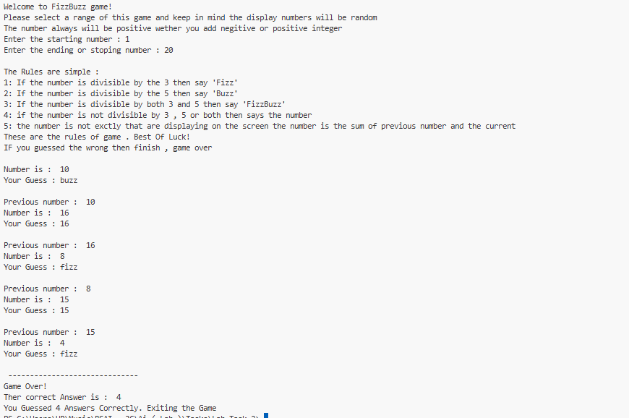

**Project 2**: Average of Movies

**1. Code Explanation**

This program calculates the **average budget of movies** and analyzes which ones are above average.

* A default dataset of movies and budgets is provided.
* User can optionally add their own movies and budgets.
* The program calculates the total budget and average.
* It prints all movies with their budgets.
* It checks which movies are above the average and by how much.
* Finally, it shows the count of above-average movies and the one with the **highest budget**.

**2. How It Works**

* The program asks the user whether to use their own dataset or the predefined one.
* It sums up all budgets -> divides by the number of movies -> gets the average.
* For each movie:
  + If its budget is higher than average -> it prints the difference.
  + Keeps track of the maximum budget movie.
* At the end, it prints the number of above-average movies and the movie with the highest budget.

**3. Why This Approach**

* This project shows **basic data handling** with lists and tuples.
* It demonstrates how to take **user input** and process custom datasets.
* It teaches how to apply **loops, conditionals, and mathematical operations** in real scenarios.
* Movies are a relatable example, making it engaging for students.

**4. Sample Output**

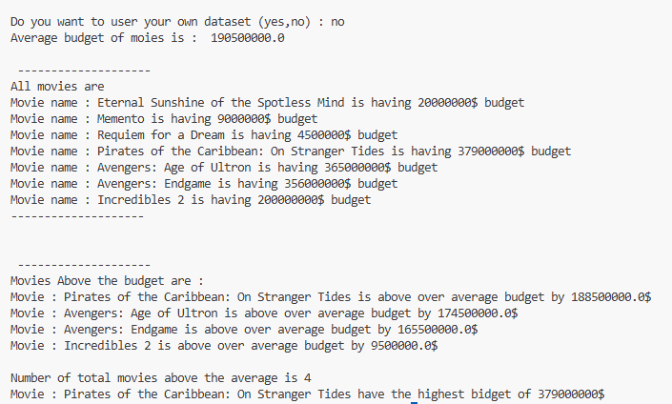

**Conclusion**

Both projects demonstrate Python programming fundamentals:

* **FizzBuzz Game** -> Focus on logic, loops, and conditional rules.
* **Movie Budget Analyzer** -> Focus on data handling, averages, and comparisons.

They fulfill the requirements of creating small, interactive, and sorted-output programs. Together, these projects show a balance between **logic-based problem solving** and **data analysis**.